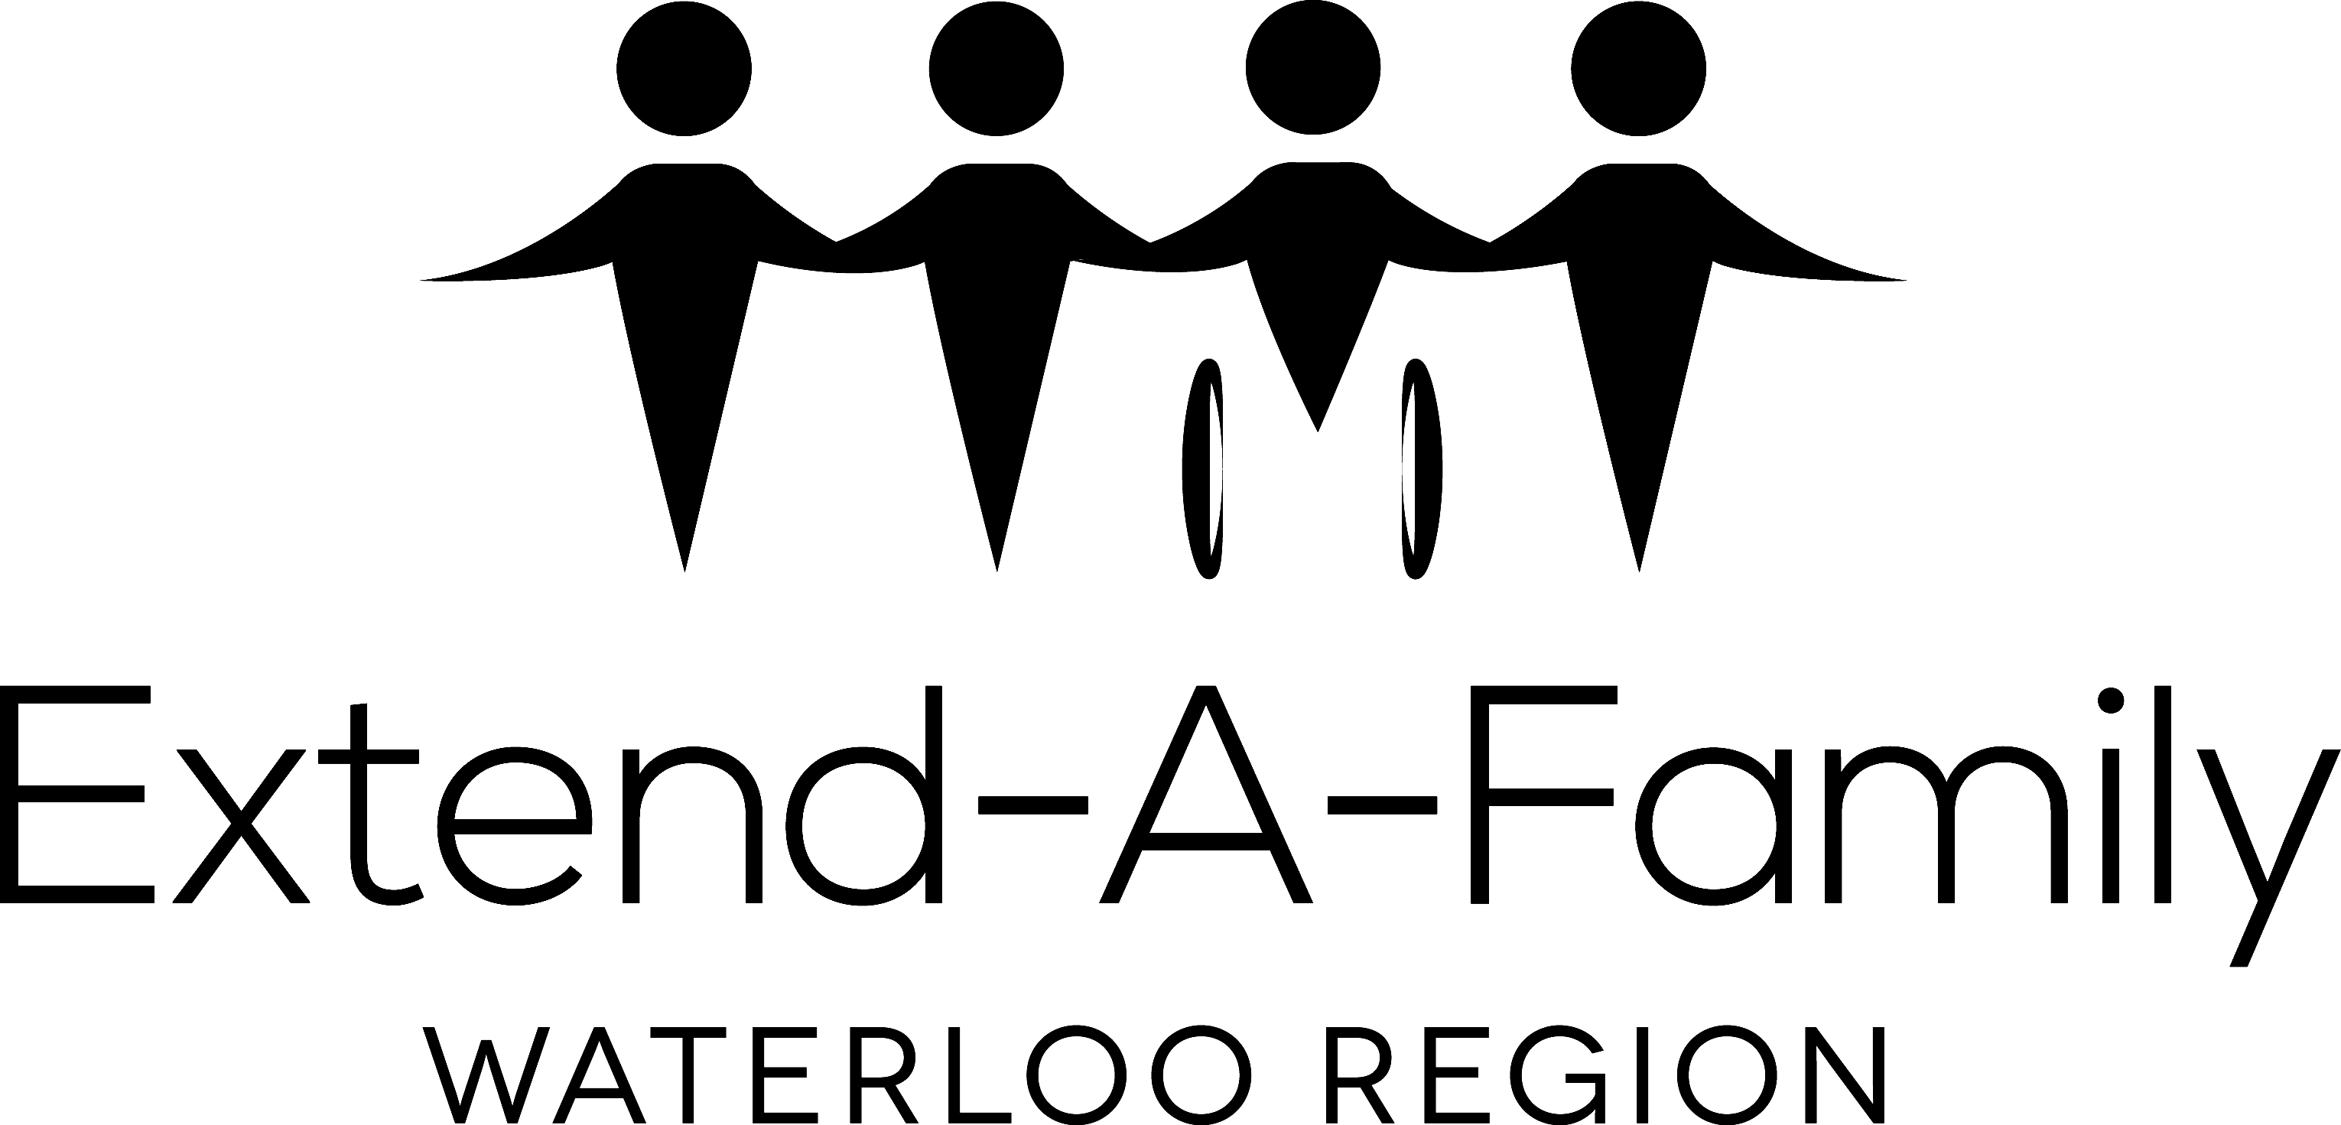
Extend-A-Family Waterloo Region
Policy to Deal with Oppressive Situations for Those We Serve

Preamble:
In keeping with our values and principles, Extend-A-Family Waterloo Region (EAF) is committed to inclusion and anti-oppression. EAF is mandated to provide a number of services to people who have a mental and/or physical disability as well as their families. We are committed to serving people by embracing everyone’s race, ancestry, place or origin, ethnicity, citizenship, creed, religion, gender, disability, sexuality, age, marital or family status or social class. Thus, to ensure that EAF continues to operate and grow as an anti-oppressive employer, we believe that inclusion and safety must be an important part of how EAF conducts its work (i.e. for both our staff and those who use our services alike). To make sure that this belief is followed by our staff, EAF has put in place policies that outline that EAF will not accept oppressive behavior directed at those we serve by staff or volunteers.

Purpose:
As the policies and procedures are in place for staff and volunteers, EAF also expects that those who use our services uphold the value of anti-oppression and be respectful of all people’s differences, including those of our staff or volunteers. The anti-oppression values followed by EAF are also consistent with the Ontario Human Rights Code. EAF places the rights of those who use our services, and the rights of a staff person or volunteer to be able to work free of harassment, discrimination and oppression, on an equal footing.

We understand that there may be times when the Human Rights Standards may not be followed and this policy has been put in place to deal with those instances. We also understand, as we have learned over the years, that most people do not intend to be disrespectful. However, because of our commitment to being an anti-oppressive organization, we cannot ignore when such instances do take place.

Scope:
This policy applies to all individuals and families served by EAF.

Responsibility:
All staff and volunteers have a responsibility, with the knowledge and support of their direct supervisor, to make the family/individual aware that they are in violation of this policy.
Ultimate responsibility to ensure that the procedures as outlined are carried out belongs to the Executive Director and, when necessary, the Board of Directors.

Policy:
Whenever a situation arises that is seen to be oppressive, steps will be taken to assist the individual/family to understand why his/her behavior is deemed to be oppressive.

If a staff member is experiencing oppression, he/she will let his/her supervisor know about the incident(s). Steps to address the situation will only be taken once there is agreement amongst the staff person, the supervisor and the executive director that in fact what happened constitutes oppression and action is warranted. The type of action will depend on the type of oppression as well as the severity of the incident.

When a family/individual behaves in a manner that has been identified as oppressive, a meeting will be set up with the family/individual and the staff member/volunteer and the supervisor to discuss the issue and expectations for change in the future.

Procedures:

Steps to be Followed:

- Contact Meeting (friendly but firm)
Those involved will include the family/individual, the staff member/volunteer and his/her supervisor (with the knowledge of the Program Manager and the Executive Director). The family/individual is welcome to have someone accompany him/her to the meeting and is in fact encouraged to do so. During this first meeting what happened is discussed with the family/individual. The reason for the meeting is to get information about what happened and explain and help him/her understand the problem and the needed changes. The meeting will be recorded and put in the family/individual’s file. After the meeting, the family/individual will be given a written outline about what happened, why it is considered to be oppressive and the steps required to correct the situation. This documentation will be given to the family/individual within one week’s time from the date of the meeting.

The family/individual will be informed that, should the issues or situation not change, that there is a possibility that services to the family/individual could be suspended or stopped altogether. At this meeting, a time is set for a follow-up meeting within the next 4 weeks.

- Suspension of Services
If the oppressive behavior continues, another meeting will be set up including the staff person, his/her supervisor and the Program Manager (with the agreement of the Executive Director). The family/individual is welcome and encouraged to have someone accompany him/her to the meeting. During this meeting with the family/individual, a written letter is given to the family/individual that explains the seriousness of the situation and that services are being temporarily suspended. The letter will inform the family/individual of the date the suspension begins, how long services by EAF will be suspended and what must happen in order for the suspension to be lifted. A meeting will be set prior to the date that the suspension period ends to review the conditions under which services will be reinstated.

- Cancellation of Services
Once again, if the oppressive behavior continues, another meeting will be held including the family/individual, the supervisor of the staff person involved the Program Manager and the Executive Director. The family/individual is welcome and encouraged to bring someone with him/her to the meeting. This step will be taken as a last resort, after the previous steps have been taken with no changed noted, or if the situation is so serious that immediate cancellation of services is indicated. A written notice of cancellation of service will be given to the family/individual, outlining the reasons for the cancellation of services, including the date that the cancellation will go into effect.

- Appeal
Any family/individual whose service from EAF has been cancelled may appeal the decision. The appeal must be made within 4 weeks of the date of the notice of cancellation. The appeal must be made in writing and addressed to the Executive Director, who will share the letter with the Chair of the Board of Directors. A meeting will be set up with the family/individual who is welcome and encouraged to bring someone to the meeting, as well as the Executive Director and the Chair of the Board of Directors/designate. Any decision made as a result of this meeting will be in writing and delivered to the family/individual within 10 days of the meeting. This decision will be final.

Passed by the Board Sept 28, 2013

