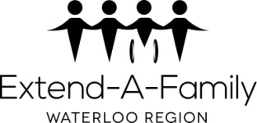
Extend-A-Family Waterloo Region
AND ANTI-OPPRESSION

Extend-A-Family Waterloo Region (EAFWR) is committed to being inclusive and welcoming to everyone.

EAFWR believes that every person has the right to be free from oppression. Oppression is behaviour that is hurtful, abusive, or leaves people out. Every person has the right to fair treatment, without hatred based on race, ethnicity (where you/they are from), class, religion, ability, age, sexuality or gender. EAFWR expects every person to treat others fairly. Oppression through words, images or actions are not allowed at EAFWR.

EAFWR works hard to make sure policies and procedures do not oppress anyone. EAFWR has an Anti-Oppression Action Committee (AOAC) that encourages conversation and celebrates difference. AOAC helps us to identify fair treatment to build a positive work culture.

If you experience behaviour that is hurtful, abusive, or makes you feel left out, we hope you will tell someone. You can do this by following Section I of the Feedback and Complaints Policy or by completing the form at the bottom of the website page: eafwr.on.ca/feedback-complaints-policy/

Anti-Oppression Action Committee

March 2017

